Soil Interactions
Your Name | Christa Leopold |  | Date
Subject/ Course | Science |  | Grade | 8th
Unit Topic or Theme | Soil Interactions |  | # of Students | Classroom
Class Length |  | Day #1_ of _5__
Central Focus/Concept, Essential Question, or Enduring Understanding
Essential Question: How is soil connected to all layers of the Earth?
Lesson Rationale and Summary
This activity is can be used as an introduction into the eighth grade year. Students will draw on prior knowledge of the lithosphere, hydrosphere and biosphere from seventh grade content. Students will be able to identify how the lithosphere, biosphere, and hydrosphere are connected using inquiry to discovery these connections. Soil will be used as a tool to convey this idea. First students will collaboratively brainstorm measureable variables/characteristics within soil, such as color, texture, permeability, and acidity. Students will propose tests, and once approved, set about testing their ideas and observing the soil variables. Students will uses these tests to identify soils as part of the lithosphere, hydrosphere, and biosphere. Students will then compare and contrast soil from their backyard and each other’s backyard soils.
Common Core Standards
Order and organization is the eighth grade common core theme. This theme focuses on helping students use scientific inquiry to discover patterns, trend, structures and relationships that may be described by simple principles. These principles are related to the properties or interactions within and between systems.
Systems can be described and understood by analysis of the interaction of their components.
Learning Objectives
Content
• Identify the components of soil using observations.
• Explain how soil is all three components of Earth.

Science Inquiry and Application
• Make a prediction
• Use appropriate mathematics, tools and techniques to gather data and information;
• Collect, analyze and interpret data;
• Think critically and logically to connect evidence and explanations;
.

Academic Language
- Soil Texture
- Water capacity pH (acid & base)
- Decomposition
- Lithosphere, Hydrosphere, & Biosphere
- Loam, Clay, Silt, & Sand
- Organic material
Planned Assessments
- Pre-Assessment: Students will draw a picture that includes the lithosphere, hydrosphere, and biosphere and define each.
- Formative Assessment: Students will complete exit tickets, answer lab questions, and worksheets.
- Summative Assessment: Students will write a paragraph explaining why the lithosphere, hydrosphere, and biosphere are connected in soil.
List Resources
- Bardgett, R. 2004The Biology of Soil: A Community and Ecosystem Approach, Oxford University Press;
- Gates, A. E., and Blauvelt. R.P. 2013."Soil." Science Online. Facts On File, Inc.
- Kaskel, A., et al. 1994. Biological Communities. Investigating Living Things. Glenco:1-4.
- Kahlon, M., Fausey, N., & Lal, R. (2012). Tillage Effects on Corn Soil-plant-water Continuum in Alfisols of Southern Ohio. Journal Of Agricultural Science (1916-9752), 4(10), 35-47. Maczulak, A. 2013. "Soil microbiology." Science Online. Facts On File, Inc.
- Moravec, C. et al. 2011. “The living Soil.” CMG Gardener Notes #212 Colorado Master Gardener: Colorado State University
- “Soil is Alive.” 2008.United States Department of Agriculture: Farm Service Agency.
- http://www.blm.gov/nstc/soil/Kids/color.html
- http://www.soil-net.com/sm3objects/activities/Combined_Pages.pdf
- http://www.nacdnet.org/education/soils
- http://www.plt.org/stuff/contentmgr/files/1/9fb7023794ea056f0c1ac0c187577c40/pdf/plt_activity_70_soil_stories.pdf
- https://www.soils.org/files/about-soils/soils-overview.pdf
- http://www.bottlebiology.org/investigations/decomp_build.html
- http://teams.lacoe.edu/documentation/classrooms/gary/plants/activities/articles/composting.html
- http://www.kirkbio.com/download_files/soda_bottle.pdf
- http://www.soils4teachers.org/lessons-and-activities
- http://www.sbwater.org/uploadedFiles/sbwater/education/BottleBiology.pdf
- http://www.wunderground.com/blog/gardencoach/comment.html?entrynum=14

THE LESSON PROCEDURES

1. READINESS (also called “Motivation” or the “Engage” segment) Allotted Time:__1 day__
- Students will be given a blank sheet of paper and asked to draw a picture to include the lithosphere, hydrosphere, and biosphere. Students will then define each word. This assignment will be used as a pre-assessment and an engagement.
- When students are finished, students will use pair-share to discuss the definitions of the terms. Students will help each other to correct any errors in the picture and the definitions.
- As a class, a definition and picture will be determined be discussing what they come up with.
  - Ask one pair-share group to come up to the board and draw their picture.
    - Expect pictures to be of the earth with each layer drawn.
  - Have three other groups to come up to the board and put their definitions.
    - Lithosphere – rock & mineral located
    - Hydrosphere- region where water is
    - Atmosphere- region where air is
    - Biosphere- region where life is
  - Do this while the other groups are working in their pair-share group.
  - Students should know what the layers mean, it is last year’s content, however this could be completed as in into to seventh grade content
ASSESSMENT: See above.

HW: Give students a baggie to collect two bags of soil.

2. CENTRAL LESSON OR ACTIVITY (Explore, Explain, Extend) Allotted Time:__4 day___
- Day 2
- Students will predict what the soil is made of.
- Students will use their critical thinking skills to come up with a way to determine what the soil is made of.
  - Show a bag of “dirt” to the class and ask them what it is? Ask the class, is this the biosphere, lithosphere, atmosphere, & hydrosphere?
  - Place out the lab report “What is soil made of?”: Have students make a prediction, observations, etc., filling in a lab report sheet as they go. (See attachment #1)
  - Students should use their dirt they brought in.
  - As a class students will come up with ways to test if it is biosphere, lithosphere, & hydrosphere with teacher guiding and helping. These tests will be performed of the following days. You may have to guide students the tests to perform.
- HW: Students are to color the different spheres in the picture. (See attachment #2)
- Day 3-5
- Students will perform three tests of their samples over the next. They will test their sample and their partners sample with each test.
- Students are to complete the lab reports associated with each test.
  - Place out the lab reports for the soil samples test. (See attachment #3)
  - Ask the class what they are testing the soils for.
  - Explain to the students that each day they will be performing the test. (See attachment #3)
  - In order to perform each test, the students place their soil samples into four plastic cups. Label each cup with their name and the test.
- Each night for homework, students should answer the conclusion question for the test they performed.
ASSESSMENT: Students will answer question based on the data collected.

3. CLOSURE / ASSESSMENT Allotted Time:__1 day______
- Students will be given a blank sheet of paper and asked to draw a picture to include the lithosphere, hydrosphere, and biosphere but of soil. Students will then give evidence of each part.
  - Students should draw a picture of the soil with rock material, air/space, water, and organisms found in soil.

Enrichment/Extension (This can’t be just tacked on; it has to be woven throughout your design.)
Extending the Lesson:
An enrichment activity could be to discuss how matter transfers from one sphere to another. (See Attachment #4) After the discussion a decomposition lab could be performed. Decomposition allows nutrients to recycle in and out of each layer of earth. Students could build a terra-column.

What is soil made of?
1
Name________________________________________________________________Date___________Period___________________
What is the soil made of? Is SOIL the biosphere, lithosphere, atmosphere & hydrosphere?
Purpose: To design tests determine what soil is made of.
Prediction: _____________________________________________________________________
Evidence of Atmosphere part of soil __________________________________________________
Evidence of Biosphere part of soil __________________________________________________
Evidence of Lithosphere part of soil __________________________________________________
Evidence of Hydrosphere part of soil __________________________________________________
Observations:
Qualitative | Quantitative
1. | 1.
2. | 2.
3. | 3.
4. | 4.
5. | 5.
Brainstorm/Critical Thinking: Come up for three “tests” to the soil for the 3 of the 4 layers of earth. (BONUS: 4 of the 4 layers)
1.

2.

3.

4.

Color the Earth
2
Name________________________________________________________________Date___________Period___________________
Color the parts of the hydrosphere blue, the lithosphere brown, biosphere green, and atmosphere red.

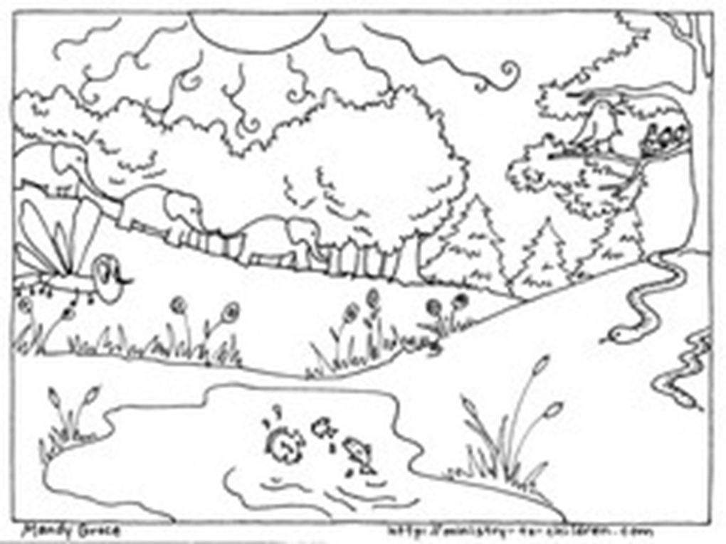

Hydrosphere Test
3
Name_________________________________________________________________Period_____________________Date________
What is the soil made of? Is SOIL the biosphere, lithosphere, atmosphere & hydrosphere?
Purpose: To determine if soil is made of water.
Prediction: _____________________________________________________________________
Procedure:
- Weigh your empty cup, than weigh you sample of soil.
- Weigh your sample of the next several days.
- Each day you weigh your sample describe what it looks like.

Observations:
Weight of cup: __________________________________
 | Weight | Describe what the soil looks like?
Day 1

Day 2

Day 3

Day 4

Conclusion: Is your soil made up of the hydrosphere? Use your evidence to support your claim!
_____________________________________________________________________________________________________________
_____________________________________________________________________________________________________________
_____________________________________________________________________________________________________________
_____________________________________________________________________________________________________________
_____________________________________________________________________________________________________________
_____________________________________________________________________________________________________________

Atmosphere Test
3
Name_________________________________________Period_____________________Date_________
What is the soil made of? Is SOIL the biosphere, lithosphere, atmosphere & hydrosphere?
Purpose: To determine if soil is made of air.
Prediction: _____________________________________________________________________
Procedure:
- Take a clean, straight-sided jam jar and fill it about a third of the way up with the soil with which you are experimenting.
- Now add the clear water until the jar of soil is almost full.
- Do you see air bubbles rising? How much air is there in soil?

Observations: Describe what you saw? How many bubbles did you see?

Conclusion: Is your soil made up of the hydrosphere? Use your evidence to support your claim!
_____________________________________________________________________________________________________________
_____________________________________________________________________________________________________________
_____________________________________________________________________________________________________________
_____________________________________________________________________________________________________________
_____________________________________________________________________________________________________________
_____________________________________________________________________________________________________________

Biosphere Test
3
Name_________________________________________________________________Period_____________________Date________
What is the soil made of? Is SOIL the biosphere, lithosphere, atmosphere & hydrosphere?
Purpose: To determine if soil is made of living things.
Prediction: __________________________________________________________________________________________________
Procedure:
- Place several sheets of newspaper on your desk. Place the soil sample onto newspaper. Using a spoon break up the soil into small clumps.
- Use a hand lens to carefully look for organisms. (If a stereoscope is available students can use it as well.) Record any organisms you find in Table 1 and the total number of each. Use Figure to determine the type of organism.
- Take a small sample of the soil and place it in a petri dish and cover it with water. Be sure that the soil is break in up. Wait two-three minutes. Carefully examine the surface of the water for organisms. Use the spoon to skim for organism off the top. This technique is called the floatation method (Glencoe Biological Lab “Biological Communities).
- Use the hand lens to identify the organism and record the identity and the total number of each in table 1.
- Throw away the soil sample and newspaper into the garbage. Wash the petri dish. Clean your work space.
Observations:
Table 1
Name of organism | Description of organism | Quantitative | Name of organism | Description of organism | Quantitative
1. |  |  | 8.
2. |  |  | 9.
3. |  |  | 10.
4. |  |  | 11.
5. |  |  | 12.
6. |  |  | 13.
7. |  |  | 14.

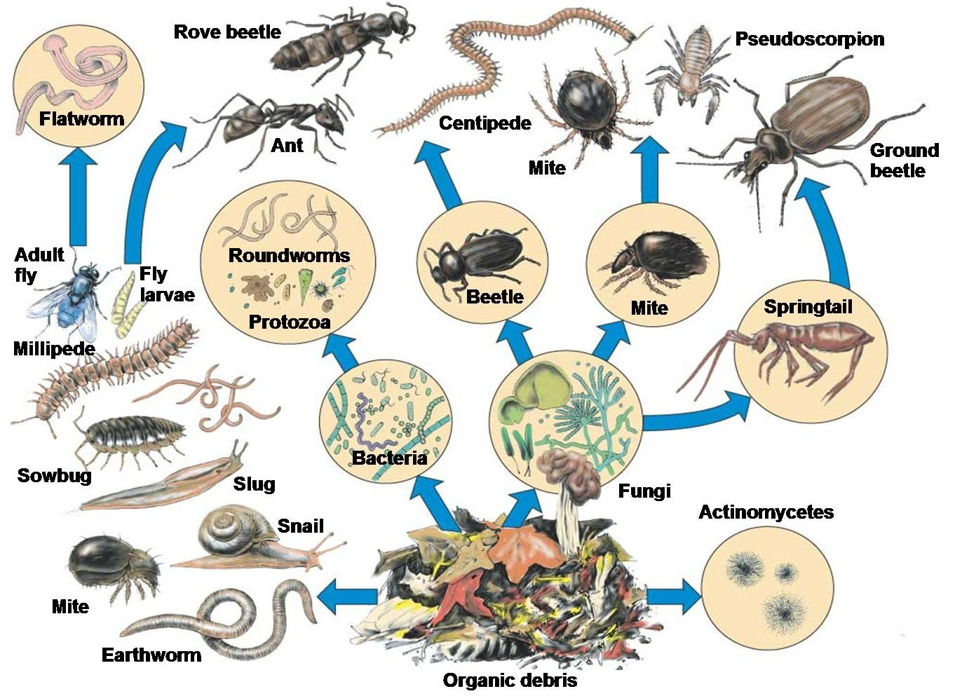Conclusion: Is your soil made up of the biosphere? Use your evidence to support your claim!
http://www.wunderground.com/blog/gardencoach/comment.html?entrynum=14 3
__________________________________________________________________________________________________________________
_________________________________________________________________________________________________________________
__________________________________________________________________________________________________________________
__________________________________________________________________________________________________________________
__________________________________________________________________________________________________________________
__________________________________________________________________________________________________________________
__________________________________________________________________________________________________________________
__________________________________________________________________________________________________________________
__________________________________________________________________________________________________________________
__________________________________________________________________________________________________________________
__________________________________________________________________________________________________________________
__________________________________________________________________________________________________________________
__________________________________________________________________________________________________________________
__________________________________________________________________________________________________________________

Lithosphere Test
3
Name_________________________________________Period_____________________Date_________
What is the soil made of? Is SOIL the biosphere, lithosphere, atmosphere & hydrosphere?
Purpose: To determine if soil is made of particles.
Prediction: _____________________________________________________________________
Procedure:
- Using the attached flow sheet and a ruler, determine if the soil has a particles.
- List the descriptions, you answered yes to on the flow chart in the table below.
Observations:
Table 1
Description of soil
1.
2.
3.
4.
5.
6.
7.

Conclusion: Is your soil made up of the lithosphere? Use your evidence to support your claim!
_____________________________________________________________________________________________________________
_____________________________________________________________________________________________________________
_____________________________________________________________________________________________________________
_____________________________________________________________________________________________________________
_____________________________________________________________________________________________________________
_____________________________________________________________________________________________________________

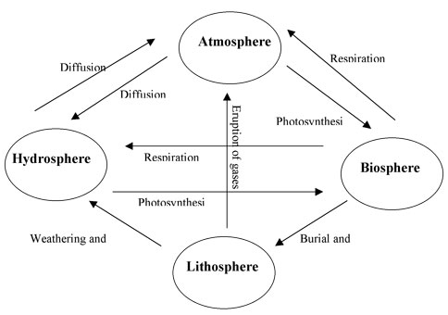
4

